Google Ads Account Setup, Campaign Types & Objectives, Keyword Match Types :

Task 1: Create a New Google Ads Account
I created and accessed a Google Ads account using my Gmail ID. After signing in, I opened the Google Ads dashboard and accessed the Campaigns section.
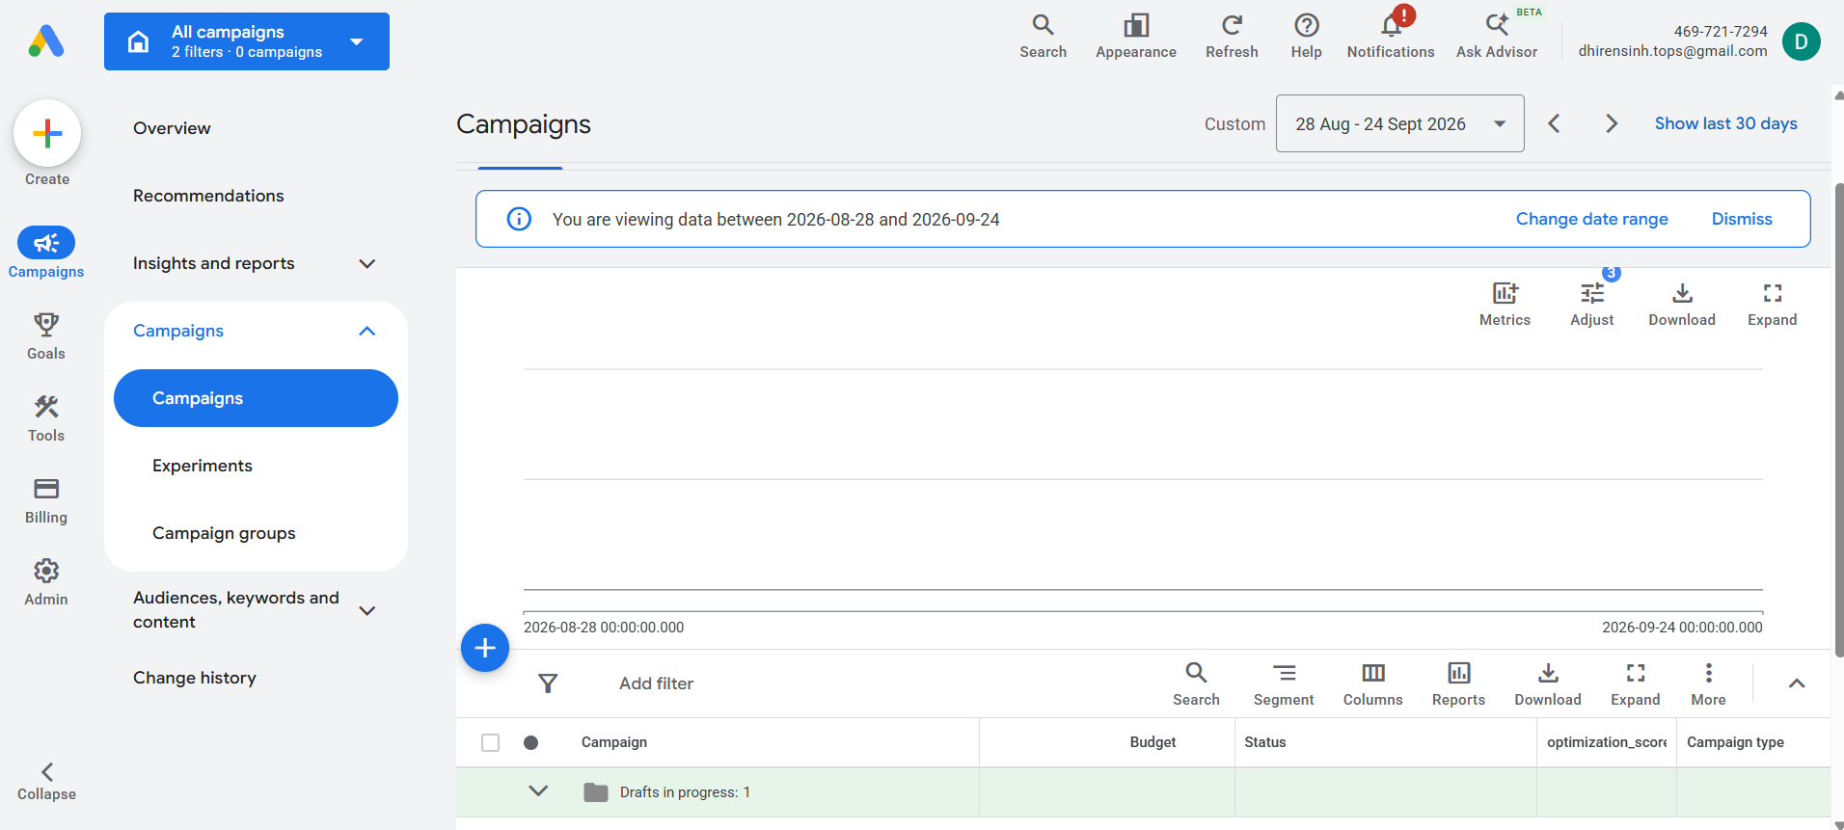
Task 2: List Three Campaign Types Available in Google Ads
Google Ads provides different campaign types that can be selected according to the advertising goal. Three common campaign types are Search Campaign, Display Campaign, and App Campaign.
Campaign Type | Description | Real-World Example
Search Campaign | Search campaigns display text advertisements when users search for products, services, or information on Google. | Zomato can advertise a food-delivery offer when users search for terms such as “food delivery near me.”
Display Campaign | Display campaigns use visual advertisements such as banners and images on websites and apps that are part of Google's advertising network. | Flipkart can use banner advertisements to promote a seasonal shopping sale.
App Campaign | App campaigns help businesses promote their mobile applications and encourage users to install or engage with them. | Spotify can promote its music-streaming application and encourage users to install the app.
1. Search Campaign
A Search Campaign is useful for reaching users who are actively searching for a product or service. For example, Zomato can display an advertisement when a user searches for food delivery or restaurants.
2. Display Campaign
A Display Campaign uses visual advertisements such as banners and images. For example, Flipkart can use Display Ads to promote a large shopping sale and reach potential customers across relevant websites and apps.
3. App Campaign
An App Campaign is designed to promote mobile applications. For example, Spotify can use an App Campaign to encourage users to download and use its music-streaming application.

Task 3: Choose a Campaign Objective
Selected Campaign Objective: Website Traffic
Example Brand: Myntra
The Website Traffic objective can help Myntra attract potential customers to its website. Myntra can show advertisements to people interested in fashion, clothing, footwear, and online shopping. When users click on the advertisements, they can be directed to relevant product or sale pages. This can increase relevant website visits and create opportunities for online purchases.
Answer in 3–4 Lines
The Website Traffic objective helps Myntra attract more potential customers to its website. Ads can be shown to users interested in fashion, clothing, footwear, and online shopping. Users who click the advertisements can be directed to relevant product or sale pages. This can increase website visits and create opportunities for online sales.

Task 4: Keyword Match Types
Target Keyword: “online food delivery”
Match Type | Syntax | Example
Broad Match | No symbols | online food delivery
Phrase Match | Quotation marks | "online food delivery"
Exact Match | Square brackets | [online food delivery]
Broad Match
Keyword:
online food delivery
Broad Match does not use quotation marks or square brackets.
Phrase Match
Keyword:
"online food delivery"
Phrase Match uses quotation marks around the keyword.
Exact Match
Keyword:
[online food delivery]
Exact Match uses square brackets around the keyword.
Final Answer
- Broad Match: online food delivery
- Phrase Match: "online food delivery"
- Exact Match: [online food delivery]

Task 5: 10 Potential Keywords for a Cricket Score App During IPL Season

No. | Keyword | Match Type
1 | cricket score app | Broad Match
2 | live cricket score | Broad Match
3 | "IPL live score" | Phrase Match
4 | "cricket live score app" | Phrase Match
5 | "IPL score app" | Phrase Match
6 | "live IPL score today" | Phrase Match
7 | [live cricket score app] | Exact Match
8 | [IPL live score] | Exact Match
9 | [IPL score app] | Exact Match
10 | [cricket score today] | Exact Match
Broad Match Keywords
- cricket score app
- live cricket score
Phrase Match Keywords
- "IPL live score"
- "cricket live score app"
- "IPL score app"
- "live IPL score today"
Exact Match Keywords
- [live cricket score app]
- [IPL live score]
- [IPL score app]
- [cricket score today]

Conclusion
Through this assignment, I learned how to set up and access a Google Ads account and how different campaign types can be used for different advertising goals. I also learned about campaign objectives such as Website Traffic and how they can support a brand's marketing activities. Finally, I learned the difference between Broad Match, Phrase Match, and Exact Match keywords and how to use the correct syntax when adding keywords to Google Ads campaigns.
These concepts are important for planning and managing Google Ads campaigns effectively and for reaching relevant audiences based on business objectives and search behavior.

